NAME OF PROJECT
CUSTOMER RETENTION PROJECT
SUBMITTED BY
PANKAJ ADHIKARI


- INTRODUCTION
Online Shopping has been one of the fastest modes of selling goods. Although there are a lot of E-retailers that sell variety of good ranging from apparel to electronics, most of the customers are not convinced by the quality service provided by the website. Hence, they tend to hop from one website to another to find the best deal of items and services. Thus, website find it difficult to retain the customers to comeback for second purchase. To address this problem most of the website tend to attract the customers with various deals and subsidies to retain them but sometimes that is not enough. This bring us to the customer activation and retention mechanism where a set of questionnaires are researched to find whether the customer revisit the website for repurchase.
- PROBLEM DEFINITION
This Data set represent the sentiment of customers during online shopping across various websites. The goal here is to determine whether the websites are able to retain the customers for second purchase. This is only possible by careful analyse the Data set provided.
- DATA ANALYSIS
In this section we perform Exploratory Data Analysis (EDA) so as to gain insight on Data.

IMPORTING LIBRARIES
We begin by importing important Libraries
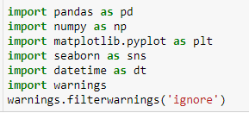

UPLOADING DATA SET
After importing Libraries we uploading the data using the excel file provided in two different DataFrames
df1 Contain the Detail Description of Dataset. Enabling us to analyse the data in encoded form
df2 Contain the Encoded form of the Dataset. Enabling us to analyse the data in encoded form

SHAPE OF DATA
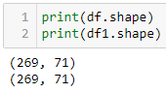
The Shape of the data is rows = 269 & column =71
RENAMING THE COLUMN
In this section we rename the column to reduce the length so that it can be presentable. We rename the Columns as given below
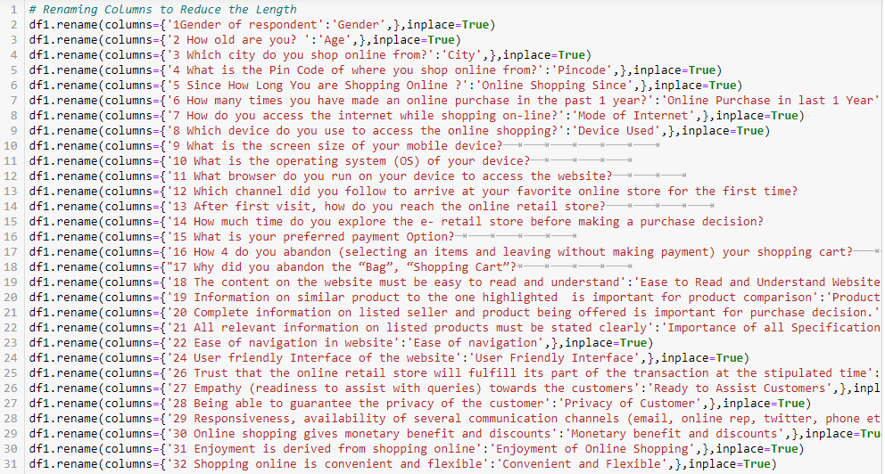

DATA INFO
We view the info of Detail data using the df.info()
DESCRIBING DATA
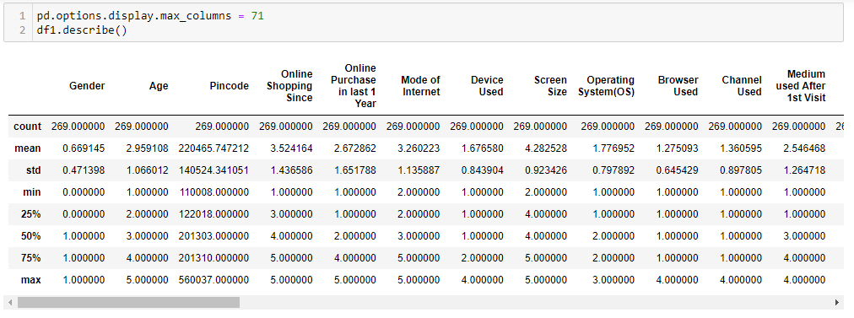

In the above figure we describe the data to view important attributes using encoded dataset (df1) and found that the encoded data is not describeable.
DESCRIBE HEAT MAP
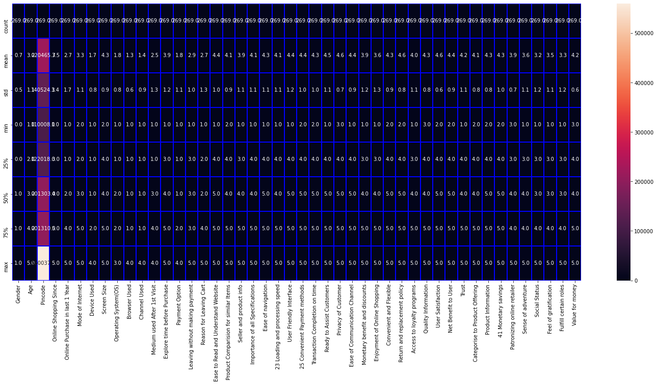
The above figure shown Describe Heat map
NULL VALUE
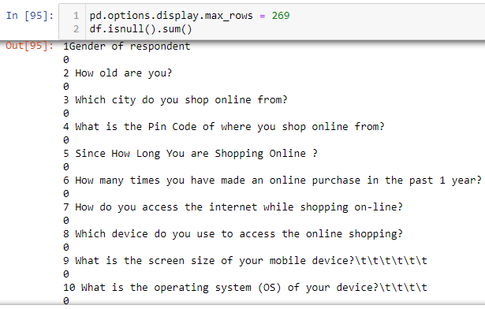

In the above figure we find that there is no missing value in the dataset

ZERO VALUE
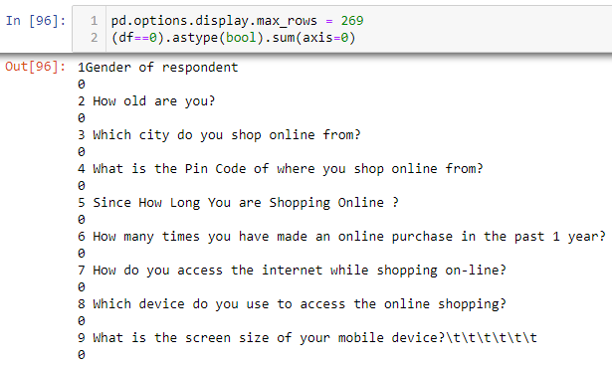
In the above figure we find that there is no zero value in the dataset

SKEWNESS

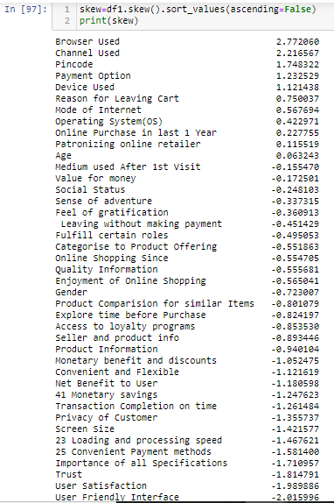
In the above figure we arrange the skewness in descending order, we find that data are positive and negative skew
SKEWNESS HEAT MAP
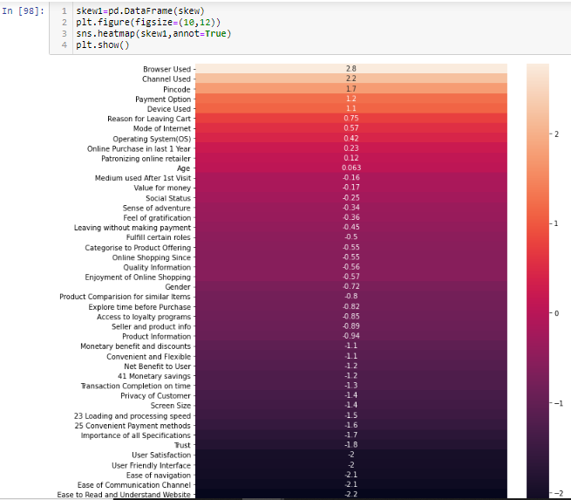

CORRELATION HEAT MAP
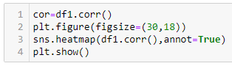

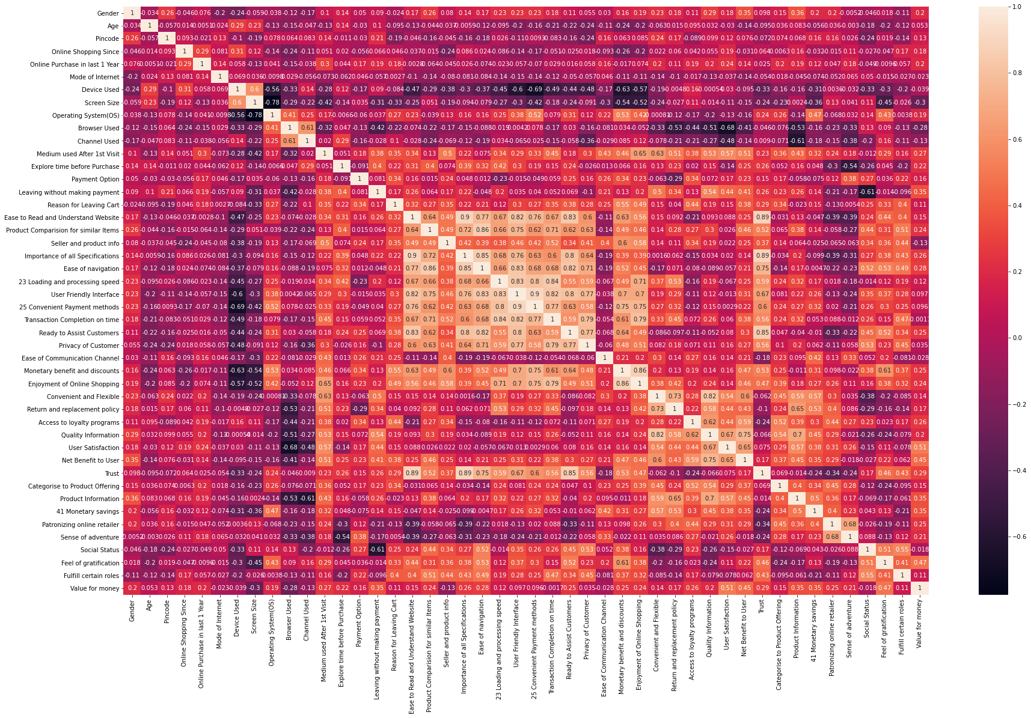
In the above Correlation Heat map, we have the following observations:
- Most of the high correlation is concentrated between “Ease to Read and Understand Website” and “Privacy of Customers”
- Screen Size and Operating System has the lowest Correlation.
- “Convenient Payment Method” and “User Friendly Interface” have high Correlation.

PLOTS AND GRAPHS
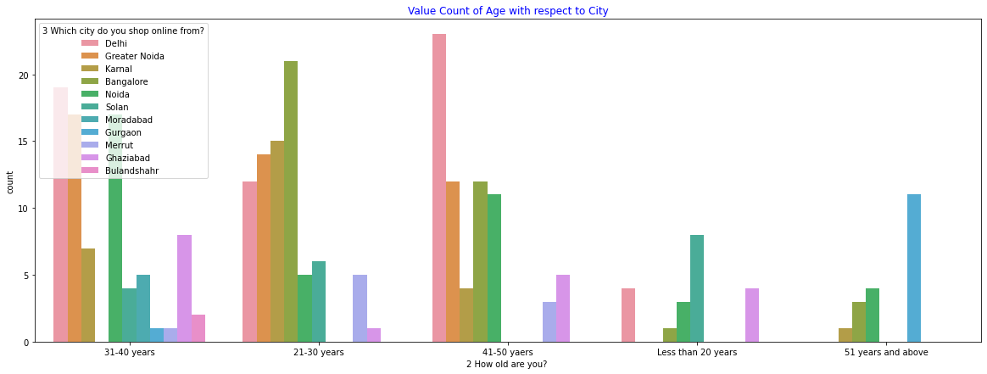
Figure : Value Count of Age with respect to City

In the above Figure we have observe the following:
- “21-30 years” age group has the highest count.
- Bangalore has the highest count in “21-30 years” age group.
- “51 years and above” age group has the lowest count.
- Bangalore have no user in “31-40 years” age group.
- Gurgaon and Moradabad have no user in “21-30 years” age group.
- Solan, Gurgaon and Moradabad have no user in “41-50 years” age group

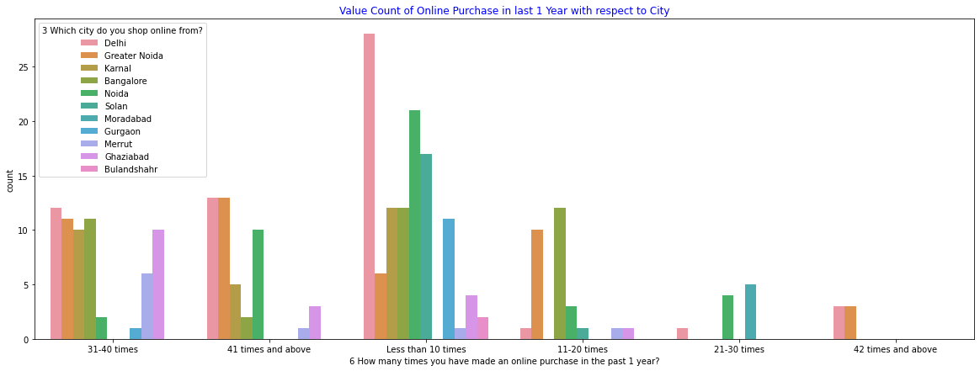
Figure : Value Count of Online Purchase in last 1 Year with respect to City
In the above Figure of we have observe the following:
- The highest count of data lies in “Less than 10 times” value in which Delhi takes a lead and Moradabad has zero count.
- Delhi has the highest combine count from all group.
- Moradabad has zero combine count from all group.
- “42 times and above” group has the lowest count.

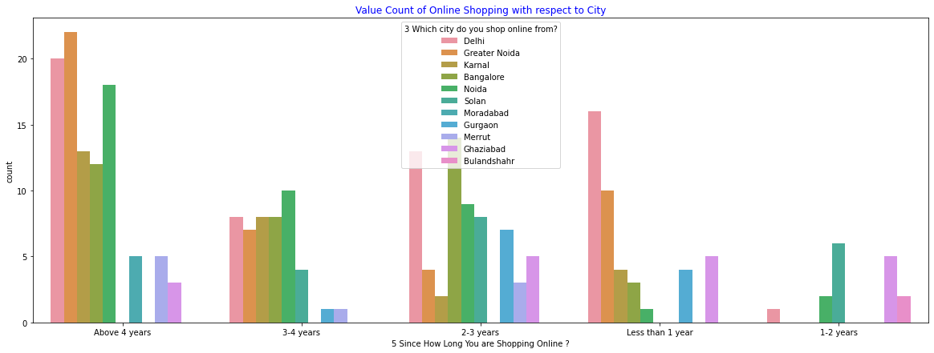
Figure : Value Count of Duration of Online Shopping with respect to City

In the above Figure of we have observe the following:
- “Above 4 years” has the highest count.
- Delhi have the highest combine count in all groups.
- Bulandshahr have the lowest combine count among all the groups.

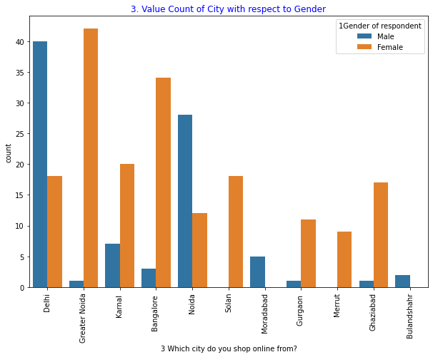
Figure : Value Count of City with respect to Gender

In the above Figure of we have observe the following:
- Female have the highest combine count among all the Cities.
- Solan and Meerut have zero Male Count.
- Moradabad and Bulandshahr have zero Female Count.
- Male and Female count is highly imbalance in Greater Noida.

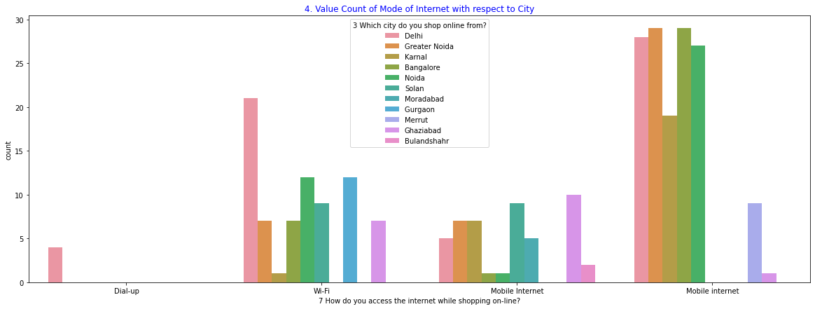
Figure : Value Count of Mode of Internet with respect to City

In the above Figure of we have observe the following:
- Mobile internet has the highest count among all the modes of internet.
- Dial-up is used in Delhi only.
- Delhi has the highest access to Internet
- Bulandshahr has the lowest access to internet.

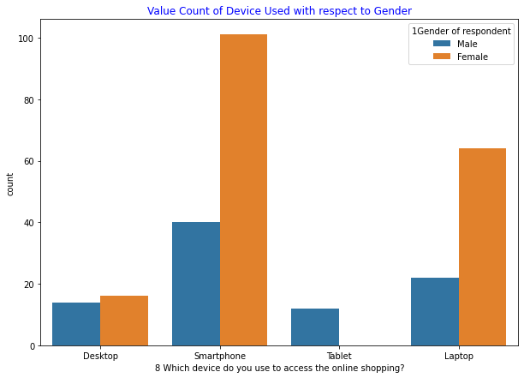
Figure : Value Count of Value Count of Device Used with respect to Gender

In the above Figure of we have observe the following:
- Female has the highest count among all the device usage.
- Female do not use tablet.
- Smartphone is the most common device.
- Desktop is usage is almost equal.

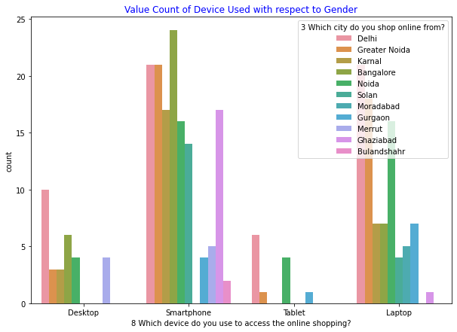
Figure : 'Value Count of Device Used with respect to City

In the above Figure of we have observe the following:
- Smartphone is the most common device.
- Bangalore has the highest use of Smartphone.
- Smartphone usage in Delhi and Greater Noda is the same.
- Tablet is least popular device.

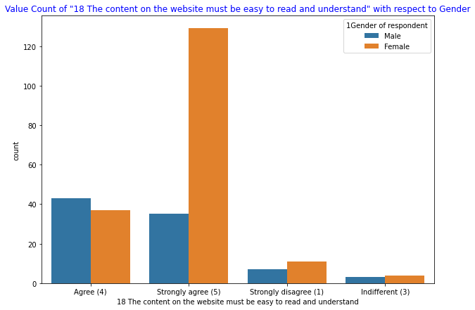
Figure : Value Count of "18 The content on the website must be easy to read and understand" with respect to Gender
In the above Figure of we have observe the following:
- Female has the highest count among all the group.
- Male has highest count in “Agree”.

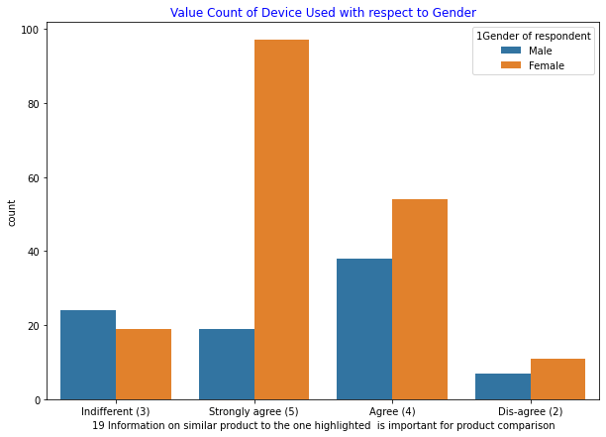
Figure : Value Count of Information on similar product with respect to Gender
In the above Figure of we have observe the following:
- Female has the highest count among all the group.
- Male has highest count in “Indifferent”.

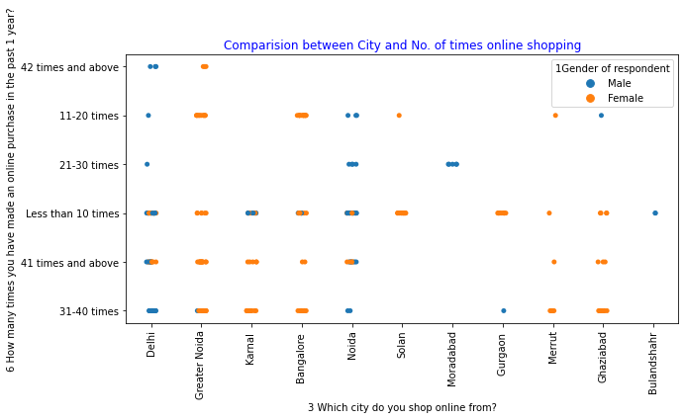
Figure : Comparison between City and No. of times online shopping

In the above Figure of we have observe the following:
- Delhi and Noida has the highest times in Online Shopping.
- Greater Noida, Merrut, Ghaziabad and Solan has mostly Female Shoppers.
- Bulandshshr and Moradabad has mostly Male Shoppers.
- Bulandshshr has the least shopper among groups.

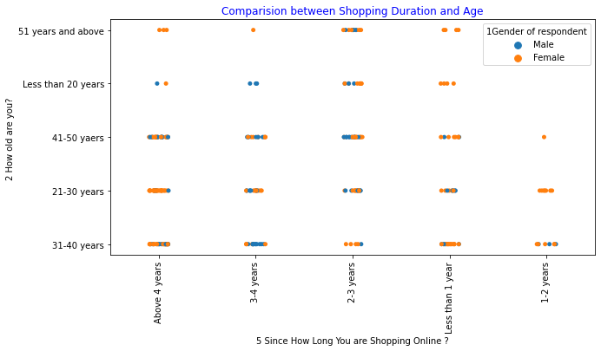
Figure : Comparison between Shopping Duration and Age

In the above Figure of we have observe the following:
- Shopper are mostly Female.
- Shopping duration 3-4 years and Age Group of Less than 20 years are all Male.

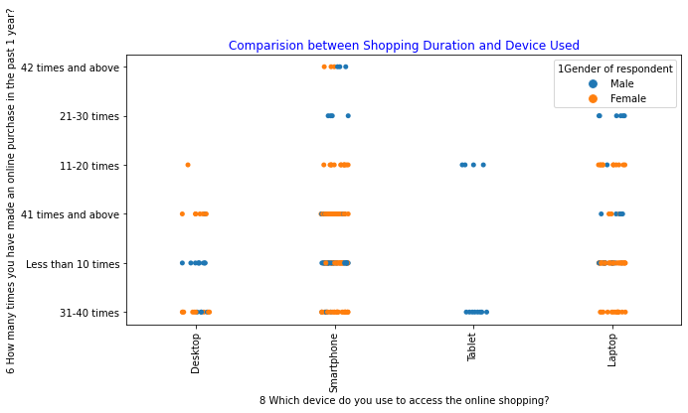
Figure : Comparison between Shopping Duration and Device Used

In the above Figure of we have observe the following:
- Smartphone has the highest duration.
- Tablet has the least duration.
- Tablet are used by Male only.

LABEL ENCODING OF COLUMNS
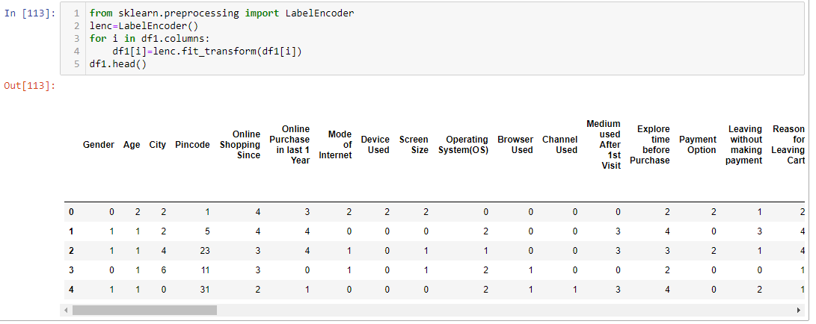
In the above Figure we use Label encoding to Encode the Data furth so that it can be use in Machine Learning.

REMOVING OUTLIERS

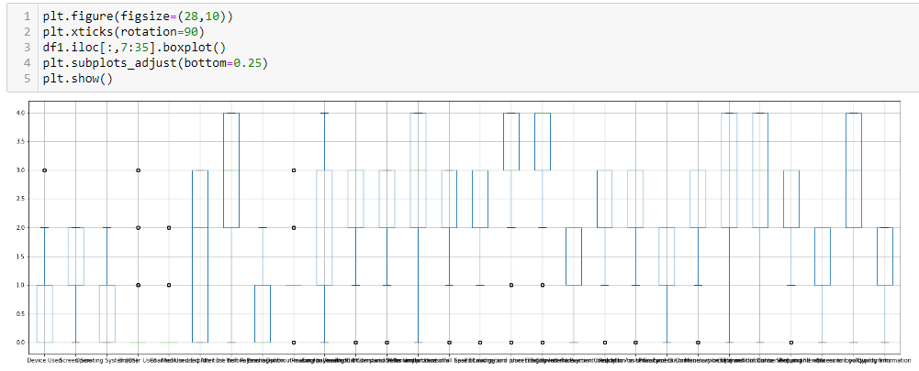
Figure : Box Plot of Columns

In the above Figure we use Boxplot and find a lot of outliers in the Dataset.
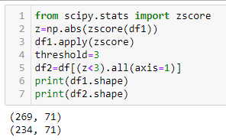
In the above Figure We use Z-Score to eliminate the outliers in the Dataset and derive df2 having 234 rows and 71 columns.
- EDA CONCLUDING REMARKS
In this Project we perform basic EDA of Dataset. As there are two file (Detail & Encoded) we used both to analyse the dataset and complete the EDA.

